EF Core 8.0 Hands-On Lab - Lab 2

Lab Overview
In this lab, we build a simple Retail Inventory System using EF Core 8.0 and SQLite. We demonstrate how to set up models, configure the DbContext, and run migrations to create the database.

1. Project Setup
Run these commands in the terminal to create the project and install EF Core:
dotnet new console -n RetailInventory
cd RetailInventory
dotnet add package Microsoft.EntityFrameworkCore.Sqlite
dotnet add package Microsoft.EntityFrameworkCore.Design

2. Models
Create a folder named 'Models' and add these two files:
Models/Category.cs
using System.ComponentModel.DataAnnotations;

namespace RetailInventory.Models;
public class Category
{
public int Id { get; set; }
[MaxLength(100)] // 👈 Fix here
public string Name { get; set; }
public List<Product> Products { get; set; } = new();
}

Models/Product.cs
using System.ComponentModel.DataAnnotations;

namespace RetailInventory.Models;
public class Product
{
public int Id { get; set; }
[MaxLength(100)] // 👈 Fix here
public string Name { get; set; }

public decimal Price { get; set; }
public int CategoryId { get; set; }
public Category Category { get; set; }
}

3. AppDbContext
Create a file named AppDbContext.cs in the root folder:
using Microsoft.EntityFrameworkCore;
using RetailInventory.Models;

namespace RetailInventory.Data;
public class AppDbContext : DbContext
{
public DbSet<Product> Products { get; set; }
public DbSet<Category> Categories { get; set; }
protected override void OnConfiguring(DbContextOptionsBuilder optionsBuilder)
{
optionsBuilder.UseSqlite("Data Source=RetailDb.db");
}
}

4. Program.cs
Replace the default Program.cs with the following:
using RetailInventory.Data;
using RetailInventory.Models;

using var context = new AppDbContext();
// Add a category if none exists
if (!context.Categories.Any())
{
var category = new Category { Name = "Electronics" };
category.Products.Add(new Product { Name = "Laptop", Price = 999.99M });
category.Products.Add(new Product { Name = "Smartphone", Price = 499.99M });
context.Categories.Add(category);
context.SaveChanges();
Console.WriteLine("Sample data added.");
}
else
{
var products = context.Products.ToList();
Console.WriteLine("Products in database:");
foreach (var product in products)
{
Console.WriteLine($"- {product.Name} (${product.Price})");
}
}

5. Run Migrations and App
To create and apply the database schema:
dotnet ef migrations add InitialCreate
dotnet ef database update
Then run the app:
dotnet run
Output (first run):
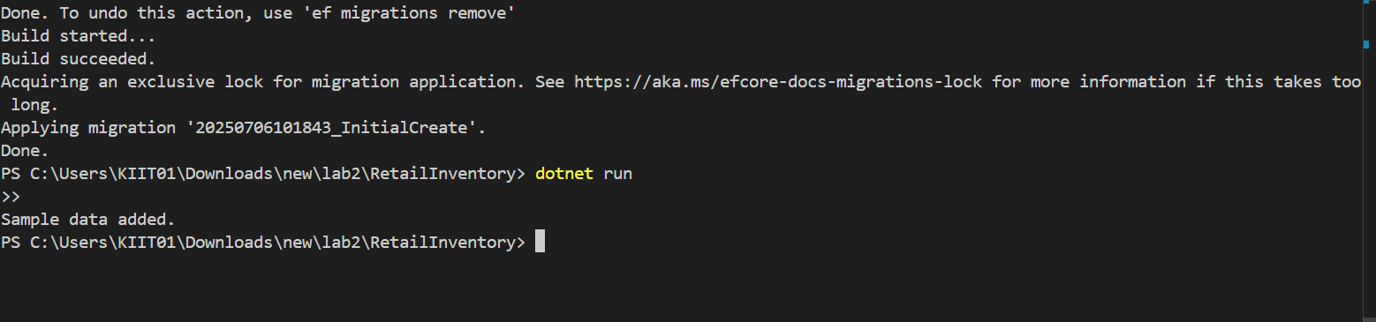
Output (subsequent runs):
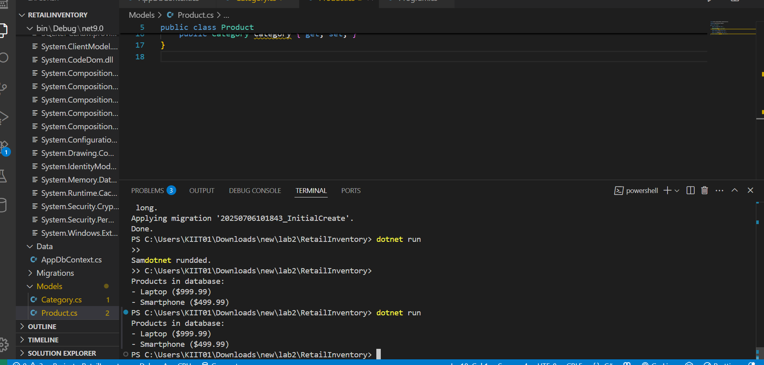
VERIFY the Data
